**JAVA PROGRAMS**

Question 2 On paper, evaluate the following Java statements and record the results: −Math.abs(-1.23) −Math.pow(3, 2) −Math.sqrt(121.0) - Math.sqrt(256.0) −Math.abs(Math.min(-3, -5))

public class Main {

public static void main(String[] args) {

double result1 = Math.abs(-1.23);

System.out.println("Math.abs(-1.23) = " + result1);

double result2 = Math.pow(3, 2);

System.out.println("Math.pow(3, 2) = " + result2);

double result3 = Math.sqrt(121.0) - Math.sqrt(256.0);

System.out.println("Math.sqrt(121.0) - Math.sqrt(256.0) = " + result3);

int min = Math.min(-3, -5);

int absMin = Math.abs(min);

System.out.println("Math.abs(Math.min(-3, -5)) = " + absMin);

}

}

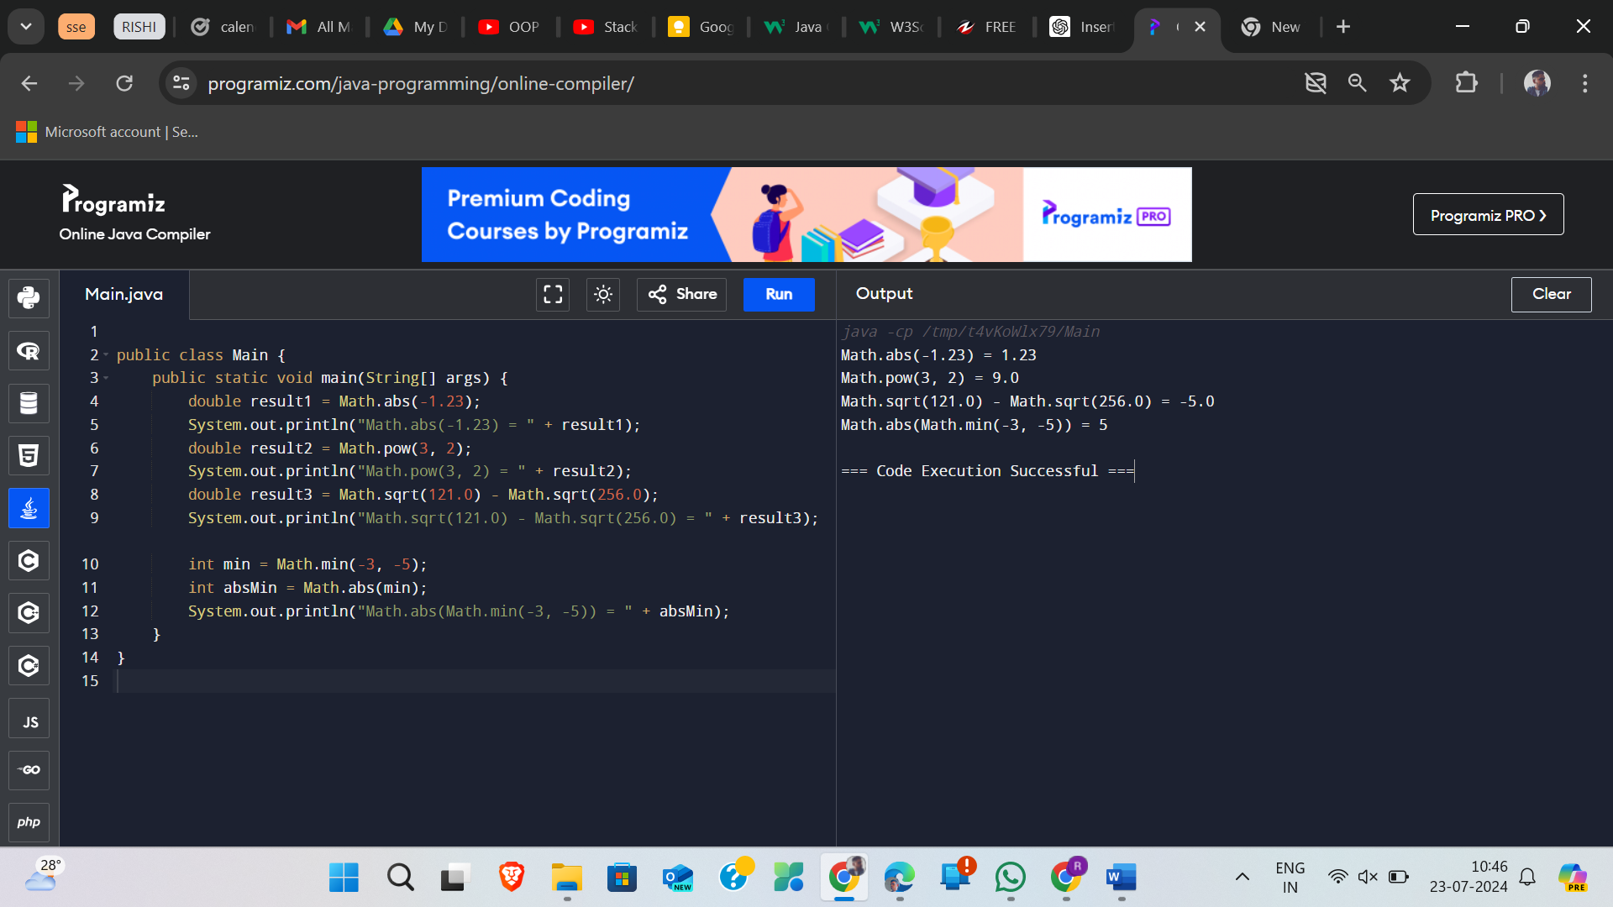

Question 3

Consider an integer variable named age

Use Math.max and Math.min methods to answer the following questions: −What expression would replace negative ages with 0? −What expression would limit the maximum age to 40?

public class Main {

public static void main(String[] args) {

int age = -5;

int ageNonNegative = Math.max(age, 0);

System.out.println("Non-negative age: " + ageNonNegative);

int ageLimited = Math.min(age, 40);

System.out.println("Limited age: " + ageLimited);

}

}

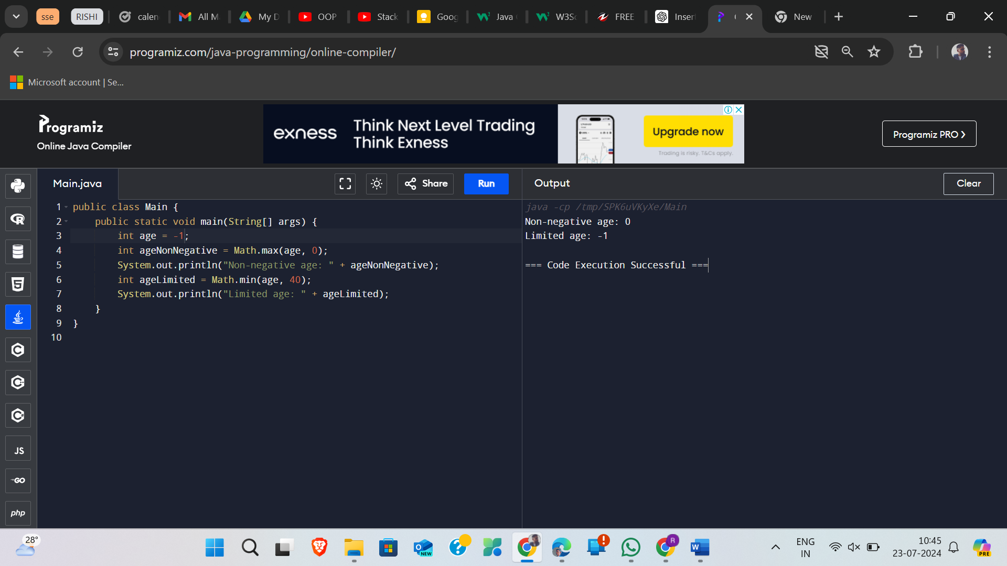

Question 4

A person’s body mass index (BMI) is computed like this: • Create a new project and add the ComputeBMI.java file to the project •Write a program that computes the BMI and rounds off the BMI 703 2 = × height weight BMI

import java.util.Scanner;

public class ComputeBMI {

public static void main(String[] args) {

Scanner scanner = new Scanner(System.in);

System.out.print("Enter your weight in kilograms: ");

double weight = scanner.nextDouble();

System.out.print("Enter your height in meters: ");

double height = scanner.nextDouble();

double bmi = weight / (height * height);

double roundedBMI = Math.round(bmi * 100.0) / 100.0;

System.out.println("Your Body Mass Index (BMI) is: " + roundedBMI);

scanner.close();

} import java.util.Scanner;

public class ComputeBMI {

public static void main(String[] args) {

Scanner scanner = new Scanner(System.in);

System.out.print("Enter your weight in kilograms: ");

double weight = scanner.nextDouble();

while (weight <= 0) {

System.out.print("Weight must be positive. Please enter again: ");

weight = scanner.nextDouble();

}

System.out.print("Enter your height in meters: ");

double height = scanner.nextDouble();

while (height <= 0) {

System.out.print("Height must be positive. Please enter again: ");

height = scanner.nextDouble();

}

double bmi = weight / (height * height);

double roundedBMI = Math.round(bmi * 100.0) / 100.0;

System.out.println("Your Body Mass Index (BMI) is: " + roundedBMI)

scanner.close();

}

}

